## Working with Visual Upgrade

**Lab Time**: 45 minutes

### Exercise 1: Working in SharePoint 2010 Sites running in UIVersion 3 Mode

In this exercise you will run a pre-provided Windows PowerShell script to create a new site collection for testing the Visual Upgrade features of SharePoint 2010. More specifically, you will run a Windows PowerShell script to create a new site collection with a top-level site and two child sites that will initially be configured to run under the older SharePoint 2007 user interface mode.

The steps in this lab assume that you are working on a SharePoint development workstation that is configured as a single-server farm and that this farm already has a Web Application that has been created at the root URL of **http://intranet.wingtip.com**. If you are working on a local SharePoint farm which has a Web Application with a different root URL, you must open the PowerShell script mentioned below and edit the URL before running it.

1. Using the Windows Explorer, look inside the lab directory which is located at a path of **C:\Student\Labs\Lab11_VisualUpgrde**. Inside this directory, you should be able to see a batch file named **LabSetup.ps1**. Right-click the file **LabSetup.ps1** and click the command **Run with PowerShell** to run the script that will create a new site collection that you will use to test the Visual Upgrade features of SharePoint 2010.

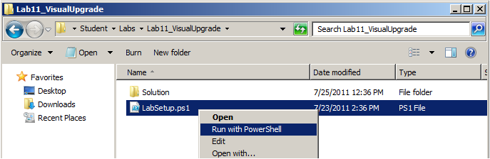

1. After the PowerShell script has created the new test site collection, it should continue to run and launch a new session of the Internet Explorer which navigates to the top-level site with a title of **Wingtip 2007 Human Resources Site**. Take note that the base URL of this site collection has been configured at **http://intranet.wingtip.com/sites/HumanResources**.

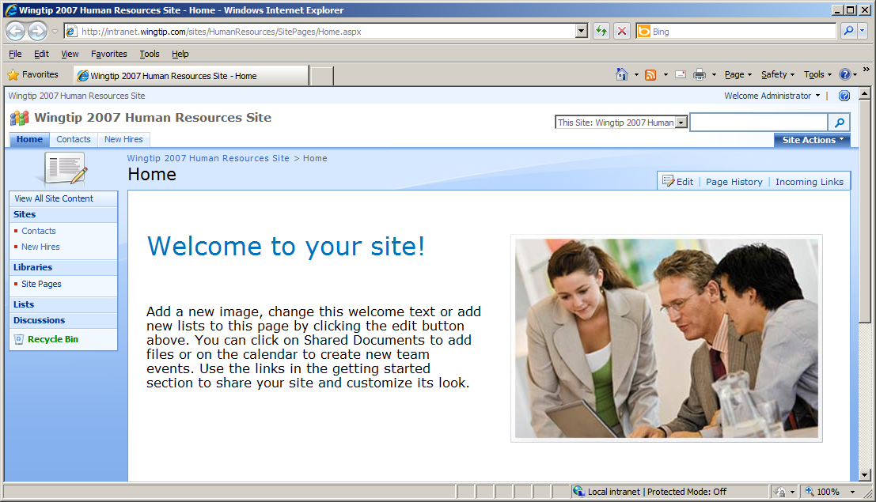

The PowerShell script you have just run created the top-level site using the **Blank Site** template and enabled the **Wiki Home Page** feature. The two child sites were both created with the **Blank Site** template as well. Even though the content for these three sites has not been migrated from an earlier version of SharePoint, they will still meet the purpose of allowing you to learn how to move sites back and forth between the older **UIVersion** mode of SharePoint 2007 and the new **UIVersion** mode of SharePoint 2010.

1. Take a moment to move around the new site collection. Note that the Top Link Bar in the top-level site provides links to the two child sites named **Contracts** and **New Hires**. Click on those links so you can see how to navigate to a child site. From the child sites, you can navigate back up to the top-level site using the breadcrumb navigation control at the top-left of the page.
2. Make sure you are at the top-level site. Locate and drop down the **Site Actions** menu on the top right-hand side of the page just under the search box. You should observe that the bottom menu command has a caption of **Visual Upgrade**. You will be using this menu command in the next exercise. For now, click on the **Site Settings** menu command to navigate to the **Site Settings** page.

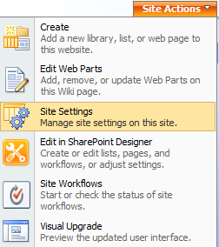

1. Take a moment to inspect what's on the **Site Settings** page of the top-level site. You should see familiar links that also appear in the SharePoint 2010 user interface. Locate the column with the caption **Site Collection Administration** on the far right. Locate and click on the **Visual Upgrade** link near the bottom which will take you to the site collection's **Visual Upgrade** page.

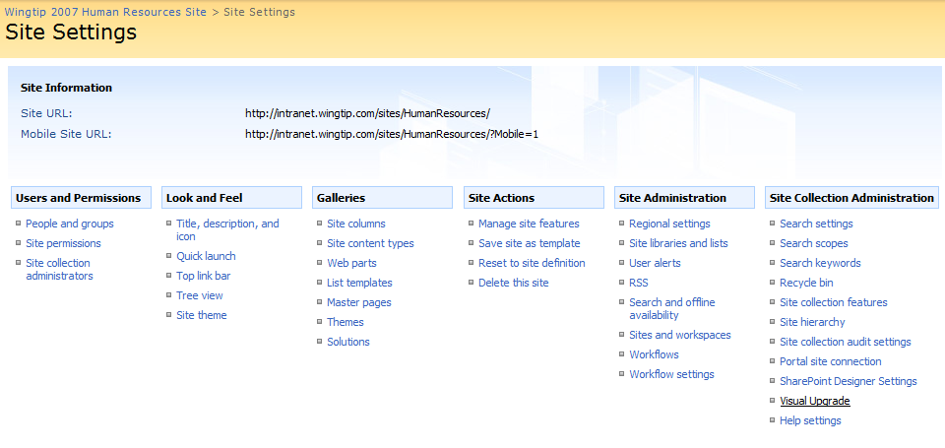

1. At this point, you will not do anything on the **Visual Upgrade** page. You should just observe that the page provides two commands named **Hide Visual Upgrade** and **Update All Sites**.

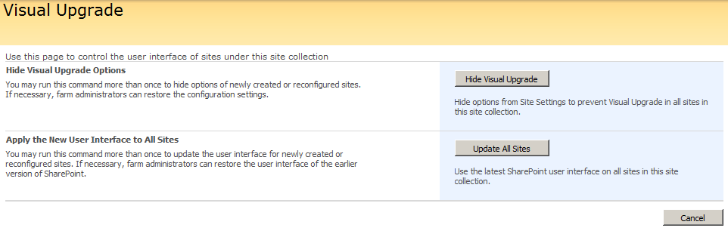

### Exercise 2: Upgrading Sites to use the new SharePoint 2010 User Interface

In this exercise you will work through the process of upgrading sites to the new SharePoint 2010 user interface. You will begin by upgrading a single child site. Next, you will configure the site collection by running the **Hide Visual Upgrade** command to remove the browser support to upgrade sites individually. The last steps will involve running the **Update All Sites** command upgrade all the sites in a site collection with a single action.

1. Navigate to the top-level site at **http://intranet.wingtip.com/sites/HumanResources**.
2. Drop down the **Site Actions** menu and click the **Visual Upgrade** menu command to navigate to the page where you can modify the Visual Upgrade settings for the current site.

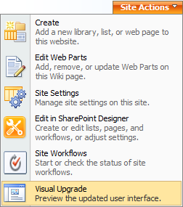

1. You should now be at a **Title, Description and Icon** page. There should be a **Visual Upgrade** section at the bottom of the page that allows you to change the user interface mode of the current site. Note that this page is different from the site collection Visual Upgrade page that you saw earlier in this lab. More specifically, this page will only allow you to change the Visual Upgrade settings for the current site but not for any other site in the current site collection.

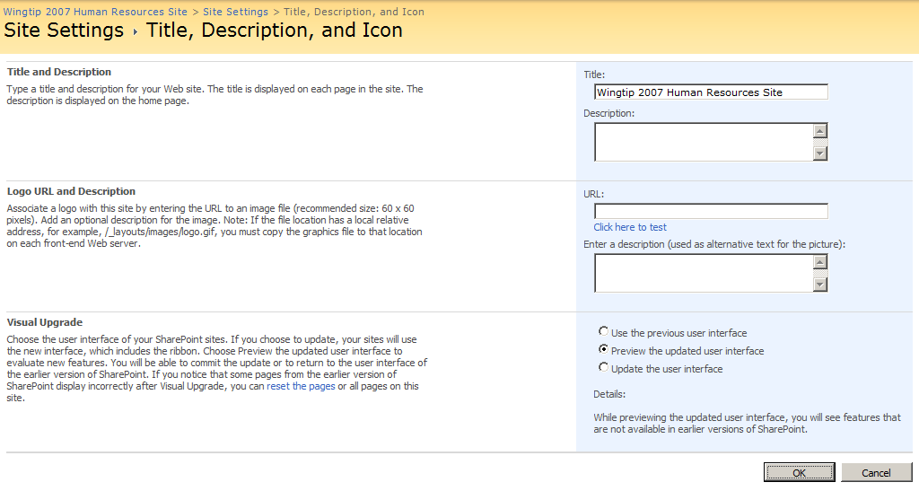

1. At this point you should be at the **Title, Description and Icon** page for the top-level site. Select the Visual Upgrade setting of **Preview the updated user interface** and click the **OK** button.
2. While in preview mode, you should see that the top-level site is displaying with the new SharePoint 2010 user interface. You should also see a message in the status bar with a yellow background indicating you are in preview mode with a convenient link to navigate back to the **Title, Description and Icon** page where you can adjust the visual upgrade settings for the current site

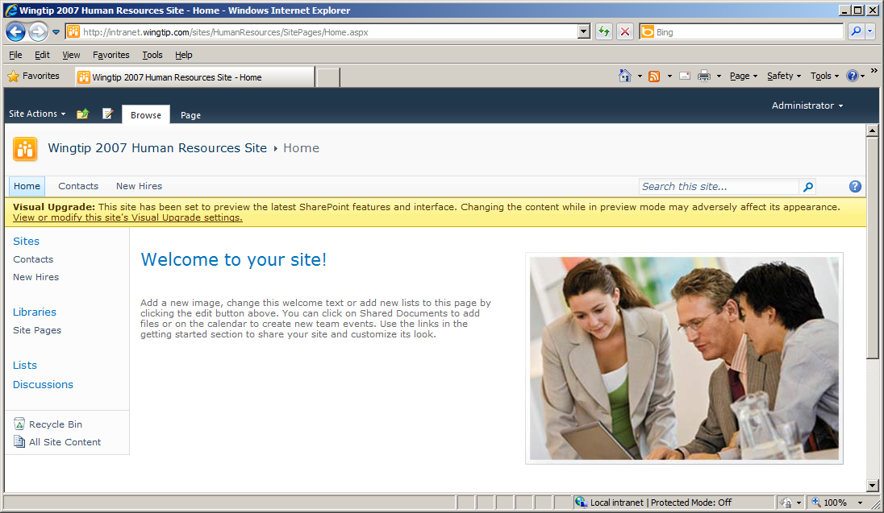

1. While the top-level site is in preview mode, navigate to one of the child sites so you can verify that they are still running under the older SharePoint 2007 user interface mode.
2. Navigate back to the home page on the top-level site.
3. Locate and click the link inside the yellow status bar with the caption of **View or modify this site's Visual Upgrade settings**. This will take you back to the **Title, Description and Icon** page for the top site. In the **Visual Upgrade** section, select **Use the previous user interface** and click the **OK** button.

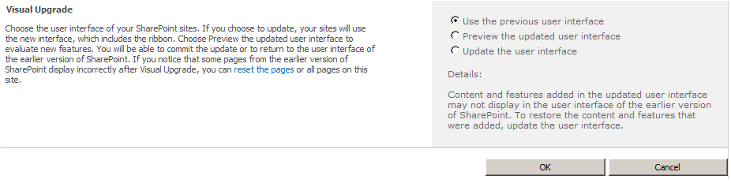

1. At this point, you should have exited preview mode and the top-level site should now be using the older SharePoint 2007 user interface.

Now that you have seen how preview mode works, you will configure one of the child sites to upgrade to the new SharePoint 2010 user interface.

1. Navigate to the **Contracts** child site by clicking the **Contracts** link in the Top Link bar.
2. Drop down the **Site Actions** menu and click the **Visual Upgrade** menu command to navigate to the page to modify the Visual Upgrade settings for the **Contracts** site.



1. In the **Visual Upgrade** section, select **Update the user interface** and click the OK button.

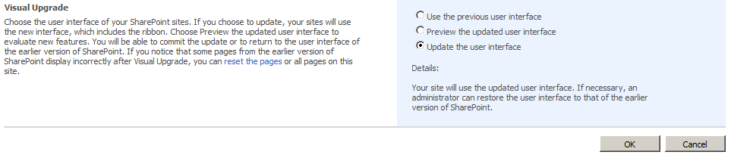

1. At this point, the **Contracts** site should be running with the new SharePoint 2010 user interface. You should also notice that there is no longer any support through the user interface in this site to change the user interface mode. In other words, once you upgrade a site to the new user interface of SharePoint 2010 in the browser, you cannot go back.

In this next step, you will configure the site collection to remove the support for upgrading sites individually. This can be a helpful option to prevent users from upgrading the user interface mode of child sites resulting in site collections running a mix of site running in both user interface modes.

1. Return to the top-level site.
2. Navigate to the **New Hires** child site by clicking the **New Hires** link in the Top Link bar.
3. Drop down the **Site Actions** menu and click the **Visual Upgrade** menu command to navigate to the page with the Visual Upgrade settings for the **New Hires** site.



1. You will not take any action in this step. You should just observe that at this point, you have the option of updating the user interface of this child site.
2. Return to the top-level site.
3. Use the **Site Actions** menu to navigate to the **Site Settings** page. Locate and click on the **Visual Upgrade** link. This action will take you to the page to configure Visual Upgrade settings for the site collection as a whole.



1. Click on the **Hide Visual Upgrade** button to disable support through the user interface to upgrade individual sites.
2. Click on the **New Hires** link on the Top Link bar to return to the **New Hires** site.
3. Drop down the **Site Actions** menu and verify there is no longer an Visual Upgrade menu command.
4. Use the **Site Actions** menu to navigate to the Site Settings page and then click the **Title, Description, and Icon** link. You should be able to verify that the user interface no longer provides the ability to upgrade the user interface for this site. The browser now only supports updating all the sites in the current site collection at once.

You will now take a single action to upgrade all the remaining sites that have yet to be upgraded.

1. Return to the top-level site.
2. Use the **Site Actions** menu to navigate to the **Site Settings** page. Locate and click on the **Visual Upgrade** link. This action will take you to the **Visual Upgrade** page where you can configure the Visual Upgrade settings for the site collection as a whole.



1. Click on the **Upgrade All Sites** button to upgrade all sites in the current site collection. Note that once you have taken this action, the browser provides no functionality to return the site collection or any individual sites to the older SharePoint 2007 user interface. At this point, moving back to the older SharePoint 2007 user mode will require writing a Windows PowerShell script as you will see in the next exercise.

### Exercise 3: Write a PowerShell Script to Update a Site's UIVersion Property

In this exercise you will write and test a Windows PowerShell script to reconfigure the site collection to go back to using the SharePoint 2007 user interface. This will show you how to restore the UIVersion settings of a site when it is required but no longer possible to do with the browser.

The Windows PowerShell script will be fairly simple and you can create and edit it using **Notepad.exe**. If you are already familiar with another Windows PowerShell script editor such as the **Windows PowerShell Integrated Scripting Environment (ISE)**, you can use that to edit the new PowerShell script instead.

1. Launch **Notepad.exe** from the Windows **Start** menu. You should be able to find the Notepad program using the path **Start >> All Programs >> Accessories >> Notepad**.
2. Click the **Save As** command from the **File** menu and save the new file with a name of **SetToUIVersion3.ps1** at a path of **C:\Student\Labs\Lab11_VisualUpgrade**.
3. Begin the script by calling **Add-PSSnapin** to load **Microsoft.SharePoint.Powershell**.

Add-PSSnapin "Microsoft.SharePoint.Powershell" -ErrorAction "SilentlyContinue"

1. Create a variable named **$SiteCollectionUrl** to track the URL of the site collection being used in this lab. Assign it a value of **http://intranet.wingtip.com/sites/HumanResources**.

Add-PSSnapin "Microsoft.SharePoint.Powershell" -ErrorAction "SilentlyContinue"

$SiteCollectionUrl = "http://intranet.wingtip.com/sites/HumanResources"

1. Create a variable named **$SiteCollection** to track a reference to the **SPSite** object for the site collection. Initialize this variable with a call to the **Get-SPSite** cmdlet. When calling **Get-SPSite** pass the **$SiteCollectionUrl** variable as the only parameter.

Add-PSSnapin "Microsoft.SharePoint.Powershell" -ErrorAction "SilentlyContinue"

$SiteCollectionUrl = "http://intranet.wingtip.com/sites/HumanResources"

$SiteCollection = Get-SPSite $SiteCollectionUrl

1. Once you have initialized the **$SiteCollection** variable with an **SPSite** object, enable Visual Upgrade configuration of the site collection through the browser by setting the **UIVersionConfigurationEnabled** property equal to **$true**.

Add-PSSnapin "Microsoft.SharePoint.Powershell" -ErrorAction "SilentlyContinue"

$SiteCollectionUrl = "http://intranet.wingtip.com/sites/HumanResources"

$SiteCollection = Get-SPSite $SiteCollectionUrl

$SiteCollection.UIVersionConfigurationEnabled = $true

Note that **$true** is an intrinsic variable value that is built into Windows PowerShell.

1. Write a **foreach** loop that enumerates through each site using the collection of sites exposed by the **AllWeb** property of the **SPSite** object. Inside the **foreach** loop, generate a message indicating a site is being updated. Update the **UIVersion** property of each site to a value of **3** and call the **Update** method to save your changes. Save the changes to your script.

Add-PSSnapin "Microsoft.SharePoint.Powershell" -ErrorAction "SilentlyContinue"

$SiteCollectionUrl = "http://intranet.wingtip.com/sites/HumanResources"

$SiteCollection = Get-SPSite $SiteCollectionUrl

$SiteCollection.UIVersionConfigurationEnabled = $true

foreach($Site in $SiteCollection.AllWebs) {

Write-Host "Updating site at" $Site.Title

$Site.UIVersion = 3

$Site.Update()

}

1. Now it's time to test your work. Using the Windows Explorer, look inside the directory at the path of **C:\Student\Labs\Lab11_VisualUpgrade** and locate the script file **SetToUIVersion3.ps1.** Right-click on the script file and select the command **Run with PowerShell**.

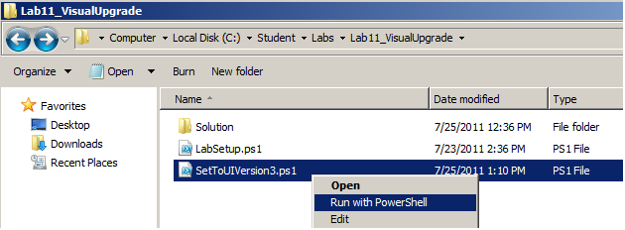

1. After the script runs, return to the site collection you have been working with in this lab at the URL of **http://intranet.wingtip.com/sites/HumanResources**. You should be able to verify that all three sites are running under the SharePoint 2007 user interface. However, you should notice that the browser does not support the ability to upgrade individual sites. For example, the **Site Action** menu in any of the three sites will not display the **Visual Upgrade** command.
2. Return to the top-level site.
3. Use the **Site Actions** menu to navigate to the **Site Settings** page. Locate and click on the **Visual Upgrade** link. This action will take you to the page to configure Visual Upgrade settings for the site collection as a whole.



1. Click on the **Upgrade All Sites** button to upgrade all sites in the current site collection. Note that once you have taken this action.
2. Verify that all three sites are now running with the SharePoint 2010 user interface.

In the preceding steps you enabled **UIVersionConfigurationEnabled** property of the site collection as a whole but not for individual sites. Now you will modify the PowerShell script to enable the **UIVersionConfigurationEnabled** property of each site. This will make it possible for users to upgrade to the new SharePoint 2010 user interface on a site-by-site basis.

1. Return to **Notepad.exe** and open the Windows PowerShell script named **SetToUIVersion3.ps1** if it is not already open. Add a new line inside the **foreach** loop just before the call to **Update** which assigns a value of **$true** to the **UIVersionConfigurationEnabled** property for each site.

Add-PSSnapin "Microsoft.SharePoint.Powershell" -ErrorAction "SilentlyContinue"

$SiteCollectionUrl = "http://intranet.wingtip.com/sites/HumanResources"

$SiteCollection = Get-SPSite $SiteCollectionUrl

$SiteCollection.UIVersionConfigurationEnabled = $true

foreach($Site in $SiteCollection.AllWebs) {

Write-Host "Updating site at" $Site.Title

$Site.UIVersion = 3

$Site.UIVersionConfigurationEnabled = $true

$Site.Update()

}

1. Save your changes to **SetToUIVersion3.ps1**.
2. Using the Windows Explorer, locate the script file **SetToUIVersion3.ps1.** Right-click on the script file and select the command **Run with PowerShell**.
3. After the script runs, return to the site collection you have been working with in this lab at **http://intranet.wingtip.com/sites/HumanResources**. You should be able to verify that all three sites are running the SharePoint 2007 user interface and that the browser now supports upgrade on individual sites as evidenced by the **Visual Upgrade** menu in **Site Actions** menu.

